

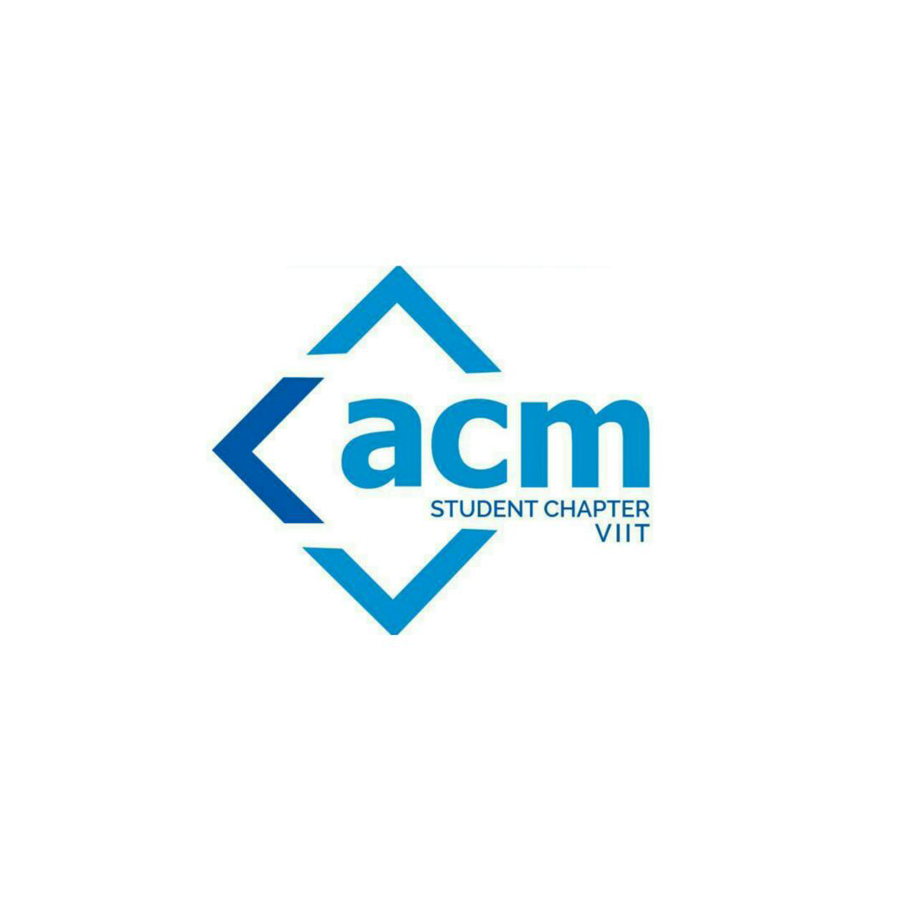

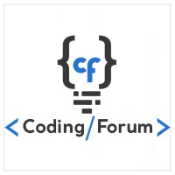

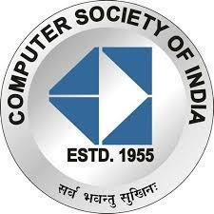

**B.R.A.C.T’S**

**Vishwakarma Institute Of Information Technology, Pune**

**Report on:** Azadi Week Day - 2

**Organized by**: CSI VIIT, ACM VIIT, Coding Forum VIIT

**Date Location**: 16th, 17th , 18th August 2021, Azadi

**AZADI WEEK**

Azadi week was an event organized by CSI,ACM and Coding Forum.This was a 7 days event which was held online and included technical competitions,guiding students towards various coding platforms.

Following were the conducted events during the week:

**DAY 1: 16th August 2021**

**Opening Ceremony**

On this day the opening ceremony of the event was held. The session was held from 4pm-5:30pm. During this session all the participants were given a brief introduction regarding the upcoming Events by anchors Mr. Hardik Shah(President of CSI VIIT) and Mr. Dishank Shah(Chair of ACM VIIT). Around 32-40 participants attended the session.

**DAY 2:17th August 2021**

**Competitive Coding and Problem Solving**

The meeting started at 4:10 pm sharp and the introduction of our speaker Mr. Atharva Adhav was given by Mr. Dishank Shah. Around 52 students were present for the event. Mr. Atharva Adhav spoke about his personal experience in Competitive coding and told about his upcoming competitive coding competition IPCP regionals. He told the importance of Competitive Coding and the languages preferred. Many Questions were asked by Dishank first, Atharva talked about the differences between Companies and

their hiring process and requirements. How competitive coding was helpful for him and his colleagues. How there is a difference between students who do competitive coding and those who don’t. The session was wonderful and many questions were asked by students and a lot of them were answered by Atharva. Then Mr. Roshan Purohit gave everyone the introduction about HackerRank and explained each and every detail required to student from how to create account to how to practice different skills to how to solve the challenges in HackerRank and then he started to give introduction about CodeChef and how it is more for Competitive Coding. The challenges and the process to solve them were explained by him and how the ranking system in CodeChef works. The entire session was very informative and interesting. It ended with the Thanking note by Dishank Shah to the Speakers and the students who joined the meeting. The response was very good and many students were asking questions and overall the whole session was very informative and knowledgeable**.**

**DAY 3:18th August 2021**

**Hands on competitive coding**

An introduction to the session was given by Aryan Gupta. Aditi Nikam, Shivam Verma, Abhidnyan Jadhav came up with some really interesting and challenging problem statements like Prefix sum problem, chat order, etc.

They explained all the problems in detail and gave sufficient explanation regarding various statements.

Many questions were asked by the participants and all were welcomed with a lot of knowledgeable answers.